Project Title
Hospital Bed (or) Operation Room Scheduling
Project Report submitted for the partial fulfilment of grade for the course

Data Structures and Algorithms -3 (25CS2103E)
in

A.Y. 2026-2027

Submitted by
Tejasreddy K (2520080027)
K Chaitanya Ram (2520090106)

Team Number: 3
Section: 12

Under the guidance of

Ms.K.Chandusha

Asst. Prof., CS&IT
Hyderabad-500090, Telangana, India.

K L (Deemed to be) University
DEPARTMENT OF COMPUTER SCIENCE ENGINEERING / COMPUTER SCIENCE AND INFORMATION TECHNOLOGY/ARTIFICIAL INTELLIGENCE & DATA SCIENCE



DECLARATION

The Mini Project Report entitled “Hospital bed (or) Operation Room Scheduling” is a record of Bonafide work of Tejasreddy K – 2520080027, K Chaitanya Ram – 2520090106, submitted in partial fulfillment for the award of B. Tech in Computer Science and Engineering/Computer Science and Information Technology/ Artifical Intelligence & data Science to the K L University. The results embodied in this report have not been copied from any other departments/University/Institute.

Tejasreddy K – 2520080027
K Chaitanya ram – 2520090106

K L (Deemed to be) University
DEPARTMENT OF COMPUTER SCIENCE ENGINEERING / COMPUTER SCIENCE AND INFORMATION TECHNOLOGY
CERTIFICATE

This is to certify that the mini project based report entitled “Hospital bed (or) Operation Room Scheduling” is a bonafide work done and submitted by Tejasreddy K – 2520080027, K Chaitanya Ram – 2520090106 in partial fulfillment of the requirements for the award of the degree of BACHELOR OF TECHNOLOGY in Department of Computer Science Engineering/ Computer Science and Information Technology/Artificial Intelligence & Data Science, K L (Deemed to be University), during the academic year 2026-2027.

Signature of the Supervisor

Signature of the HOD Signature of the External Examiner

ACKNOWLEDGEMENT

The success in this project would not have been possible but for the timely help and guidance rendered by many people. Our wish to express my sincere thanks to all those who has assisted us in one way or the other for the completion of my project.

Our greatest appreciation to my guide, Ms.K. Chandusha, Asst. Prof, CS&IT which cannot be expressed in words for his/her tremendous support, encouragement and guidance for this project.

We express our gratitude to Dr. P.Venkateshwar Rao (CSE)/Dr. Khaja Shareef (CSIT)/ Dr. Sreenath Itikela (AI&DS), Head of the Department for Computer Science Engineering/ Department for Computer Science and Information Technology/Department of Artificial Intelligence and Data Science for providing us with adequate facilities, ways and means by which we are able to complete this project-based Lab.

We thank all the members of teaching and non-teaching staff members, and also who have assisted me directly or indirectly for successful completion of this project. Finally, I sincerely thank my parents, friends and classmates for their kind help and cooperation during my work.

Tejasreddy K - 2520080027
K Chaitanya Ram - 2520090106

TABLE OF CONTENTS

S.No. | Contents | Page no.
1. | Abstract | 6
2. | Introduction | 7
3. | Literature survey | 8-9
4. | Problem Statement and Objectives | 10
5. | Hardware and Software requirements | 11
6. | Implementation | 12-15
7. | Results & Discussion | 16-17
8. | Conclusion & Future Scope | 18
9. | References | 19

1.ABSTRACT

The Hospital Bed and Operation Room Scheduling System is designed to improve the utilization of hospital resources by automating patient allocation and scheduling. The system manages patient records, hospital bed availability, operating room schedules, and medical staff assignments. It considers patient priority, emergency admissions, treatment duration, and resource availability when generating schedules. Data Structures and Algorithms such as Priority Queues, Greedy Scheduling, Quick Sort, Knuth-Morris-Pratt (KMP) string matching, Graphs, and Maximum Flow are incorporated to demonstrate efficient searching, prioritization, and resource allocation. The system provides an administrative dashboard to monitor resources, view patient information, and analyze scheduling performance. A React frontend communicates with a Java Spring Boot backend through REST APIs. The prototype demonstrates how algorithm-based scheduling can help reduce resource conflicts, improve resource utilization, and support organized hospital operations. Future enhancements can include database integration, real-time updates, advanced optimization, and detailed performance analytics.

Team Members:
- [Tejasreddy K, 2520080027]
- [K Chaitanya Ram, 2520090106]

- INTRODUCTION

Hospitals manage multiple patients, beds, operating rooms, doctors, and other medical resources every day. Manual allocation and scheduling can become difficult when several patients require treatment simultaneously or when emergency admissions occur. Inefficient scheduling may lead to unnecessary waiting, resource conflicts, and underutilization of available facilities.
The Hospital Bed and Operation Room Scheduling System addresses these challenges through a software-based scheduling platform. The system maintains patient and resource information and provides an interface for administrators to monitor availability and scheduling activities. The scheduling process uses Data Structures and Algorithms to prioritize patients, search records, and organize resource assignments.
The frontend is developed using React, while the backend is implemented in Java using Spring Boot and REST APIs. The project demonstrates the practical application of DSA concepts to a real-world healthcare resource management problem. It also provides a foundation for future improvements involving persistent databases, advanced scheduling algorithms, and real-time hospital information.

- LITERATURE SURVEY

1. Healthcare Scheduling in Optimization Context: A Review
This review examines scheduling problems in healthcare, including patient admission, nurse scheduling, operating-room scheduling, and resource allocation. It discusses optimization methods used to improve patient flow, reduce operational costs, and utilize hospital resources effectively. The findings support the need for algorithmic approaches in hospital scheduling systems.
2. Application of Operational Research Techniques in Operating Room Scheduling Problems
This study reviews operational research techniques used to plan and schedule operating rooms. It examines patient characteristics, performance measures, uncertainty, and scheduling methods. Its focus on operating-room efficiency is closely related to the project's room allocation and scheduling modules.
3. A Systematic Review of Research Design and Modeling Techniques in Inpatient Bed Management
This research reviews approaches for managing inpatient beds, including simulation and mathematical optimization. It highlights challenges caused by changing patient demand, length of stay, and unexpected admissions. These findings provide a foundation for designing bed availability and allocation features.
4. A Comprehensive Review on Operating Room Scheduling and Optimization
This review analyzes operating-room scheduling research and optimization techniques, including practical constraints such as staff availability, limited resources, and uncertain treatment durations. It emphasizes performance measures such as resource utilization and waiting time. These factors are directly relevant to the proposed scheduling dashboard.
5. Integration of Decision Levels in Operating Room Scheduling Problems
This research examines operating-room scheduling at strategic, tactical, and operational levels. It discusses mathematical programming models and optimization algorithms that integrate different scheduling decisions. It provides useful context for extending the project's scheduling engine.
6. Operating Room Planning and Surgical Case Scheduling: A Review of Literature
This review classifies surgical scheduling problems according to planning levels, scheduling strategies, patient characteristics, uncertainty, and solution methods. It helps identify the different constraints involved in scheduling operations and allocating hospital resources.
7. Hospital Bed Management and Patient-to-Bed Assignment
Research on bed management examines the assignment of patients to suitable beds while considering capacity, patient needs, and changing demand. This work supports the design of a bed management module that tracks availability and helps prevent inappropriate allocations.
8. Priority Queue-Based Scheduling
Priority queues are commonly used in computing systems to process higher-priority tasks before lower-priority tasks. In this project, the data structure provides a way to order patients according to priority and emergency status. The final allocation must still respect resource availability and clinical decisions.
9. Graph-Based Resource Conflict Detection
Graph models represent relationships between entities and can be used to identify conflicts among resources or scheduled activities. The project uses a graph representation to demonstrate resource-conflict checking. A complete implementation must also validate time intervals and staff availability.
10. Maximum-Flow-Based Resource Allocation
Maximum-flow algorithms determine the maximum possible flow through a network subject to capacity constraints. A hospital allocation model can represent patients and resources as nodes in a network, with edges representing feasible assignments. Additional constraints are required to account for clinical suitability, time slots, and staff availability.

- Problem Statement and Objectives

Problem Statement
Manual hospital bed and operating-room scheduling can lead to inefficient resource utilization, patient waiting, and allocation conflicts, particularly during emergency admissions.
Problem Description
Hospitals must allocate limited beds, operating rooms, and medical staff to patients with different priorities and treatment requirements. The scheduling process becomes challenging when resources are occupied, staff are unavailable, or emergencies require changes to existing plans. A systematic algorithm-based approach is needed to organize allocations and identify conflicts.
Objectives
- Develop a centralized interface to manage patient records, beds, operating rooms, and medical staff.
- Implement priority-based patient ordering using a Priority Queue.
- Apply searching algorithms, including KMP, to locate patient records efficiently.
- Demonstrate greedy scheduling and sorting techniques for organizing allocation decisions.
- Represent resource relationships using graphs and demonstrate conflict checking.
- Implement a Maximum Flow algorithm to explore capacity-constrained resource allocation.
- Provide an administrative dashboard with resource availability and scheduling information.
- Calculate basic resource-utilization and waiting-time metrics.
- Integrate the React frontend with a Java Spring Boot backend through REST APIs.

- HARDWARE AND SOFTWARE REQUIREMENTS
Hardware Requirements
- Processor: Intel Core i3 or equivalent and above.
- RAM: Minimum 4 GB; 8 GB recommended.
- Storage: At least 2 GB of free space for project files and dependencies.
- Display: Standard monitor or laptop display.
- Network: Internet connection for installing dependencies and accessing documentation.
Software Requirements
- Operating System: Windows 10/11, Linux, or macOS.
- Programming Language: Java 17 or later.
- Backend Framework: Spring Boot.
- Frontend Technologies: React, JavaScript, HTML, and CSS.
- Frontend Build Tool: Node.js and Vite.
- Build Tool: Apache Maven.
- Development Environment: Visual Studio Code or IntelliJ IDEA.
- API Testing: Postman or Thunder Client.
- Browser: Google Chrome, Microsoft Edge, or Firefox.
- Data Storage: In-memory Java collections for the current prototype; a database can be integrated in a future version.

- IMPLEMENTATION

Module 1: Patient Management and Priority Queue
PriorityQueue<Patient> queue = new PriorityQueue<>(
(a, b) -> {
if (a.getPriority() != b.getPriority()) {
return Integer.compare(
a.getPriority(), b.getPriority()
);
}

boolean emergencyA =
a.getAdmissionType().equalsIgnoreCase("Emergency");

boolean emergencyB =
b.getAdmissionType().equalsIgnoreCase("Emergency");

return Boolean.compare(!emergencyA, !emergencyB);
}
);

for (Patient patient : patients) {
queue.offer(patient);
}

while (!queue.isEmpty()) {
Patient nextPatient = queue.poll();
System.out.println(nextPatient.getName());
}
Module 2: Patient Search Using KMP
public boolean search(String text, String pattern) {
if (pattern == null || pattern.isEmpty()) {
return true;
}

if (text == null || text.isEmpty()) {
return false;
}

int[] lps = buildLPS(pattern);
int i = 0, j = 0;

while (i < text.length()) {
if (Character.toLowerCase(text.charAt(i)) ==
Character.toLowerCase(pattern.charAt(j))) {
i++;
j++;

if (j == pattern.length()) {
return true;
}
} else if (j != 0) {
j = lps[j - 1];
} else {
i++;
}
}

return false;
}
Module 3: Scheduling and Resource Allocation
PatientPriorityQueue queue = new PatientPriorityQueue();

for (Patient patient : patients) {
queue.add(patient);
}

while (!queue.isEmpty()) {
Patient patient = queue.poll();

OperationRoom room =
findAvailableRoom(patient, conflictGraph);

if (room != null) {
// Create a schedule for the selected patient.
// Validate availability before committing allocation.
}
}
Module 4: REST API and Dashboard
@RestController
@RequestMapping("/api/patients")
@CrossOrigin(origins = "http://localhost:5173")
public class PatientController {

private final HospitalRepository repository;

public PatientController(HospitalRepository repository) {
this.repository = repository;
}

@GetMapping
public List<Patient> getPatients() {
return repository.getPatients();
}
}

- RESULTS & DISCUSSION
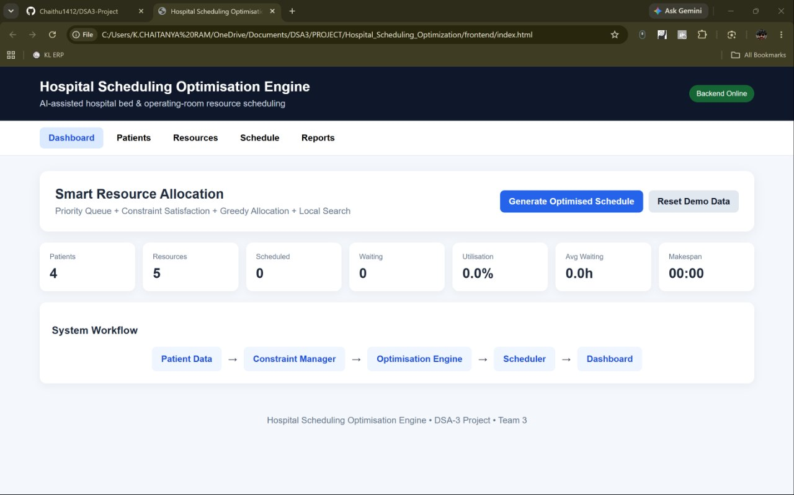
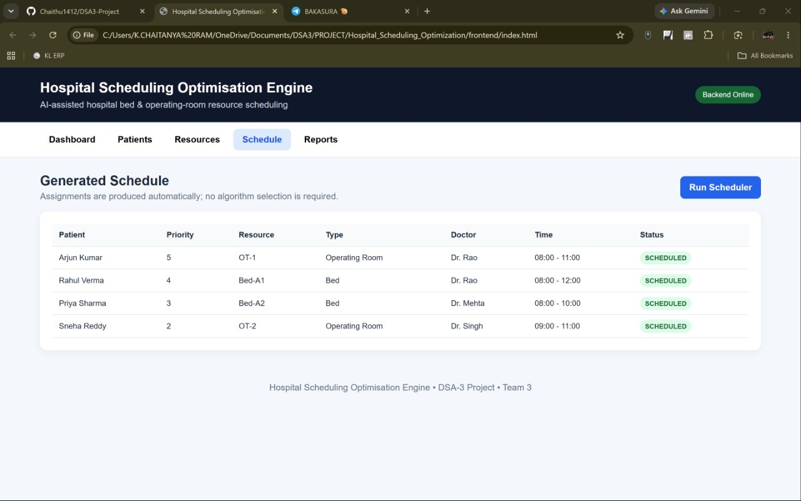
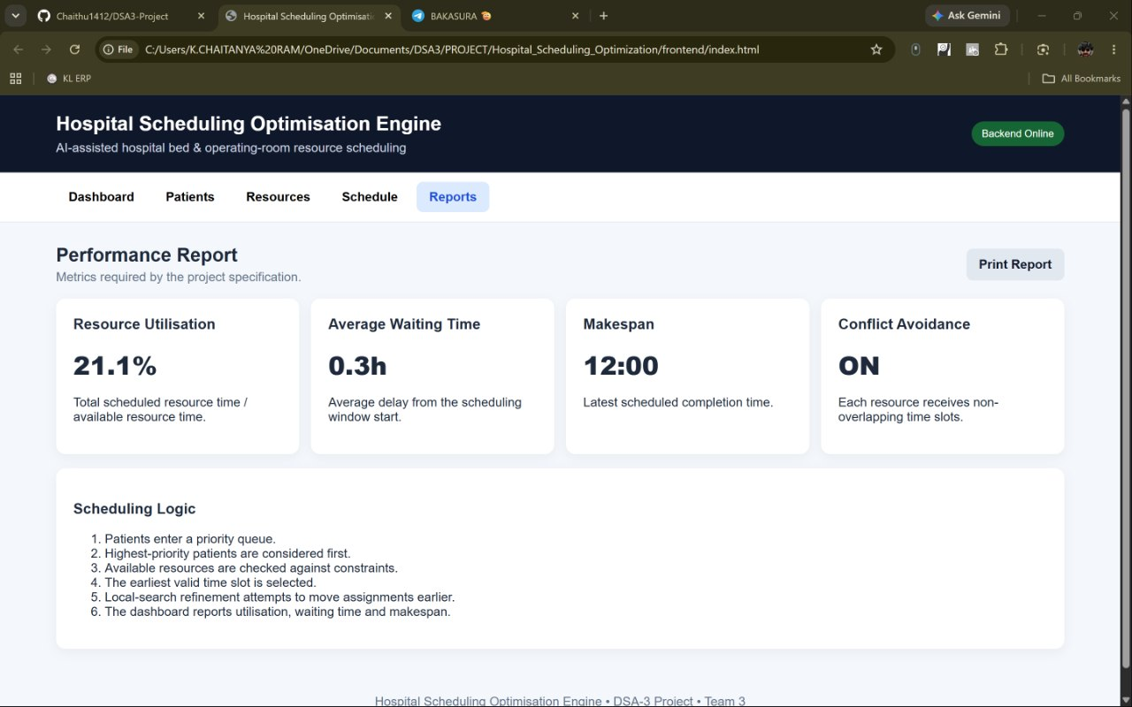
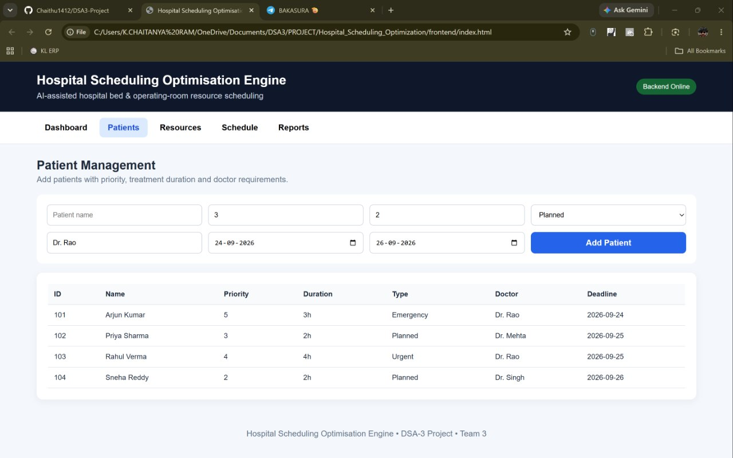

- CONCLUSION & FUTURE SCOPE
Conclusion
The Hospital Bed and Operation Room Scheduling System demonstrates how Data Structures and Algorithms can be applied to hospital resource management. The project integrates patient management, resource availability, priority-based processing, searching, scheduling, and dashboard visualization through a React frontend and a Java Spring Boot backend. Priority Queues, KMP string matching, sorting, graph representations, and Maximum Flow provide practical demonstrations of concepts from the DSA-3 syllabus. The prototype establishes a foundation for organizing patient allocation and monitoring resource information. However, production-level use would require persistent storage, robust conflict validation, clinical suitability checks, security controls, and validation against realistic hospital workflows.
Future Scope
- Database integration: Use MySQL or PostgreSQL to store patient records, resources, and schedules persistently.
- Advanced scheduling: Incorporate treatment durations, time-slot overlap checks, doctor availability, and resource compatibility.
- Emergency rescheduling: Update schedules when emergency admissions, cancellations, or resource failures occur.
- Optimization: Evaluate approximation algorithms and other optimization techniques to improve allocation quality.
- Analytics: Calculate resource utilization, average waiting time, schedule conflicts, and patient throughput using recorded data.
- Real-time updates: Use WebSockets or server-sent events to update the dashboard when resource availability changes.
- Security: Introduce authentication, role-based access control, audit logs, and appropriate patient-data protection.

- REFERENCES

- Al Amin, M., Baldacci, R., and Kayvanfar, V. (2025). “A Comprehensive Review on Operating Room Scheduling and Optimization.” Operational Research. https://doi.org/10.1007/s12351-024-00884-z
- “Healthcare Scheduling in Optimization Context: A Review.” Health and Technology (2021). https://doi.org/10.1007/s12553-021-00547-5
- Gür, Ş., and Eren, T. (2018). “Application of Operational Research Techniques in Operating Room Scheduling Problems: Literature Overview.” https://pmc.ncbi.nlm.nih.gov/articles/PMC6020466/
- “A Systematic Review of Research Design and Modeling Techniques in Inpatient Bed Management.” Computers & Industrial Engineering (2019). https://doi.org/10.1016/j.cie.2018.10.033
- “Integration of Decision Levels in Operating Room Scheduling Problems: Systematic Review and Proposition of a Decision Support Framework.” Computers & Operations Research (2025). https://doi.org/10.1016/j.cor.2025.107063
- Zhu, S., Fan, W., Yang, S., Pei, J., and Pardalos, P. M. (2019). “Operating Room Planning and Surgical Case Scheduling: A Review of Literature.” https://doi.org/10.1007/s10878-018-0322-6
- Spring Boot Documentation. https://docs.spring.io/spring-boot/index.html
- React Documentation. https://react.dev/
- Knuth, D. E., Morris, J. H., and Pratt, V. R. (1977). “Fast Pattern Matching in Strings.” SIAM Journal on Computing, 6(2), 323–350. https://doi.org/10.1137/0206024
- Cormen, T. H., Leiserson, C. E., Rivest, R. L., and Stein, C. (2022). Introduction to Algorithms, 4th edition. MIT Press. https://mitpress.mit.edu/9780262046305/introduction-to-algorithms/

